Project Design Phase
Proposed Solution
Date | November 2026
Student Name | Rachabathula Gnana Sruthi
Project Name | Automated Network Request Management
Maximum Marks

Proposed Solution
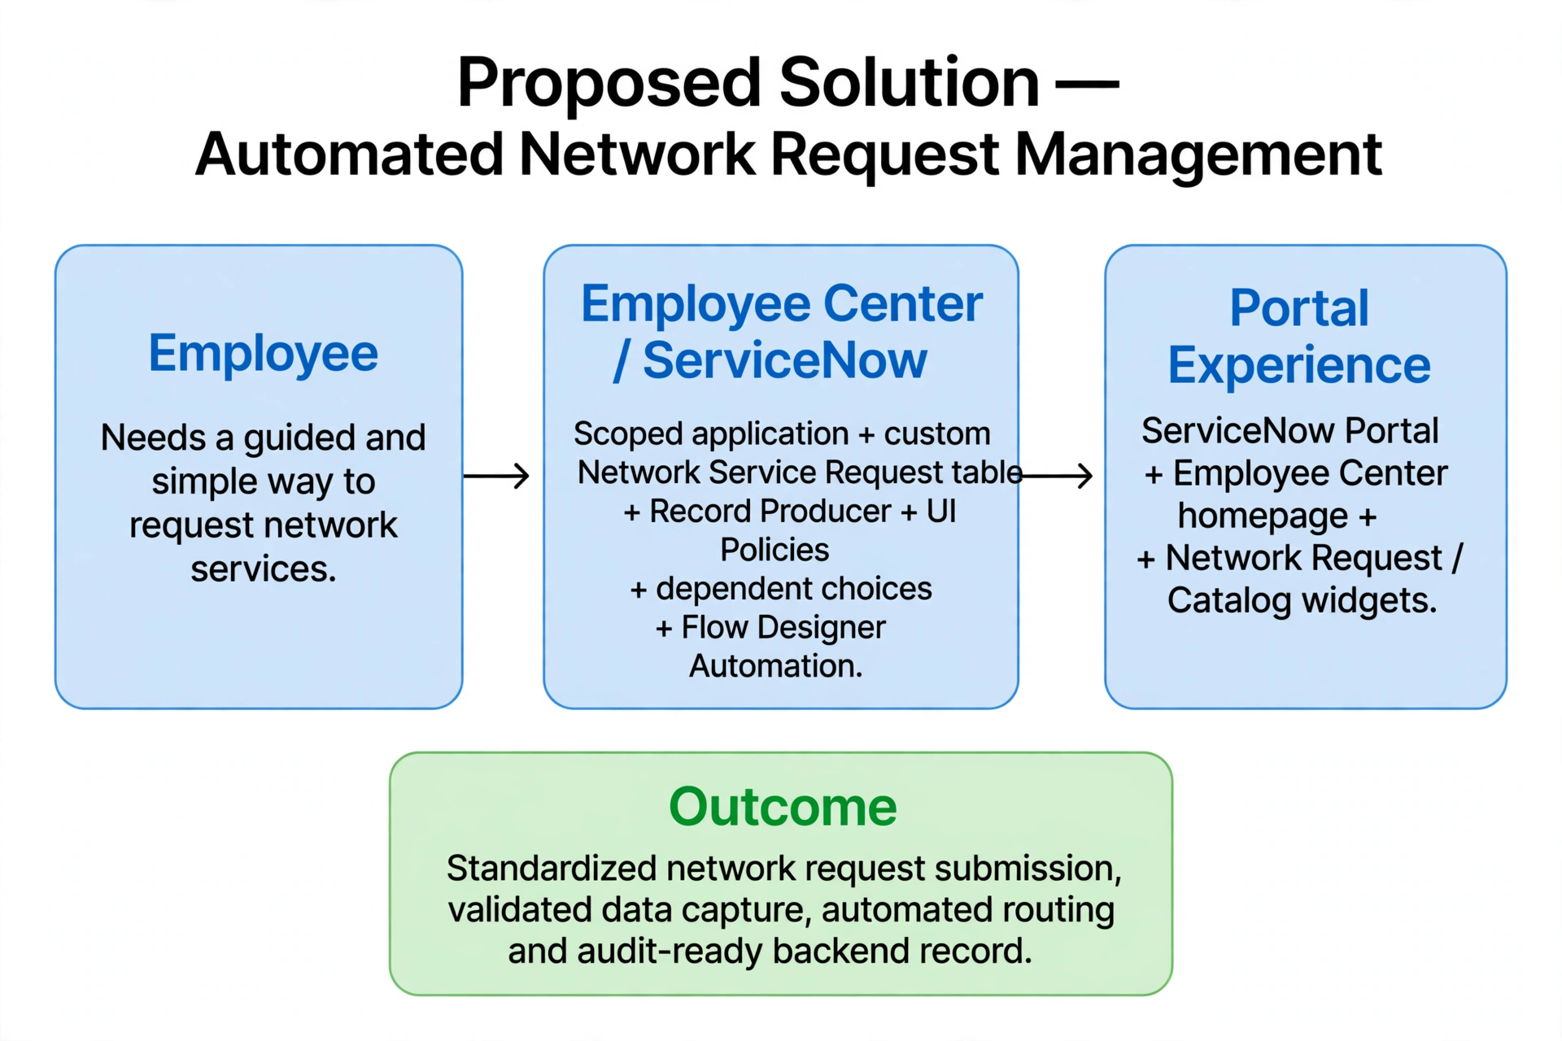
The proposed solution is a scoped ServiceNow application named Automated Network Request Management. A custom network requests table stores service requests and parameter details. A Network Request Record Producer provides form variables mapped to the table. A Service Portal (/sp) and customized portal homepage expose the functionality to requesters. Catalog UI Policies and dependent choices enforce appropriate form behavior, while custom widgets improve navigation and presentation.

S.No. | Parameter | Description
1 | Problem Statement | Requesters need a consistent, structured way to submit network service and port access requests.
2 | Idea / Solution description | Scoped ServiceNow application with portal-based network submission, Record Producer, and Flow Designer automation.
3 | Novelty / Uniqueness | Combines ServiceNow configuration, dependent choices, UI Policies, and custom portal widgets for network tracking.
4 | Social Impact / Customer Satisfaction | Makes network provisioning faster and simpler, improving consistency and reducing manual configuration errors.
5 | Business Model / Revenue Model | Internal enterprise IT service management solution; no direct revenue model is required.
6 | Scalability of the Solution | Can be extended with automated approvals, multi-tier routing, notifications, dashboards, and advanced reporting.

